

PROJECT MANAGEMENT | CAD DEPARTMENT

Vantage Riser Checklist

**Project Name:**

**Project Manager Name:** Steven Cottam

**Project Sponsor:** Steven Cottam

**Project Team Member Names:** All CAD Customers

**Date:** 08-18-2017

**Prepared by:** Alex Lundin

# Table of Contents

## Follow the Riser Checklist

## View VRULES.txt file for your responsibilities

## Use VMAIN to fill out data in blocks

## Use VCONTROLLER to fill out data in blocks

## Create extraction from RISERLAYOUT.dwg

## Use GSRVANTAGE from blank template file

# Vantage Riser Checlist

## Follow the Riser Checklist

* **Create the RISER-LAYOUT.dwg**
  1. This drawing is where you will use functions to wire blocks together and fill out data.
  2. This wire is for your visualization only so you can see how the devices will connect when generating the riser.
  3. These algorithms are not intended to create perfect floor plan wiring; they are designed to reduce the burden of data entry on Engineers.
  4. Keep the floor plan wiring as an internal step for our teams at Legrand; it is not authorized to send out to the field

## View VRULES.txt file for your responsibilities.

* **Open your RISER-LAYOUT.dwg**
* **Type VRULES into AutoCAD**
* **Read the very first paragraph to understand what the codes expect from you**

## Configure command line size

* **Expand command line to 3 lines**
  1. Expand command line to read prompts
     1. Example shows how 1 line command line is unclear

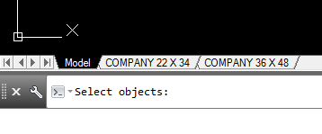

* + 1. You can stretch the command line upwards, by clicking on the top edge

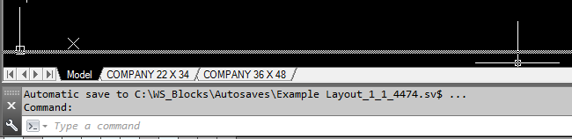

* + 1. Now it’s clear what AutoCAD is prompting to select

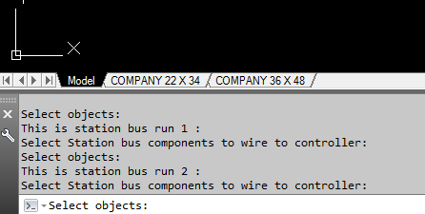

## Use VMAIN to fill out data in blocks

* **Type VMAIN into AutoCAD**
  1. Always use this command first, especially on Revisions
  2. It resets data in the AutoCAD blocks that the next command uses
  3. Follow prompts to connect devices, some are multi line prompts
* **Select all blocks and cable in area to wire**
  1. These sequences use orange to highlight LCAP blocks that will be wired during the command
  2. Here the DLM parts stay blue

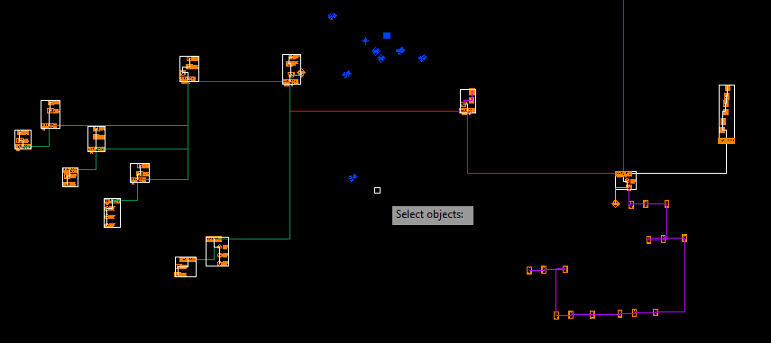

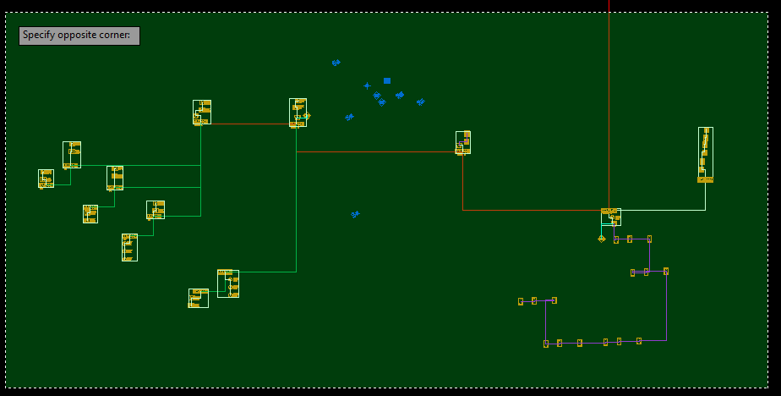

* **Select the first main panel**

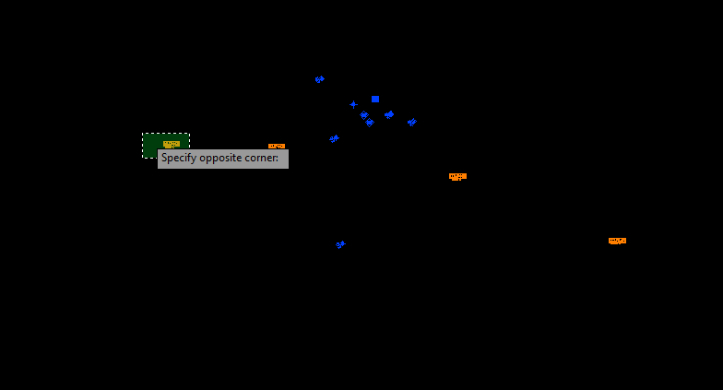

* **Enter the number of this main panel**

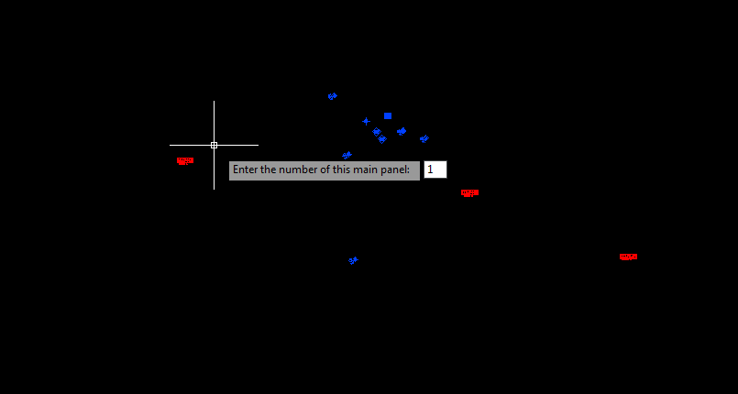

* **VMAIN complete**

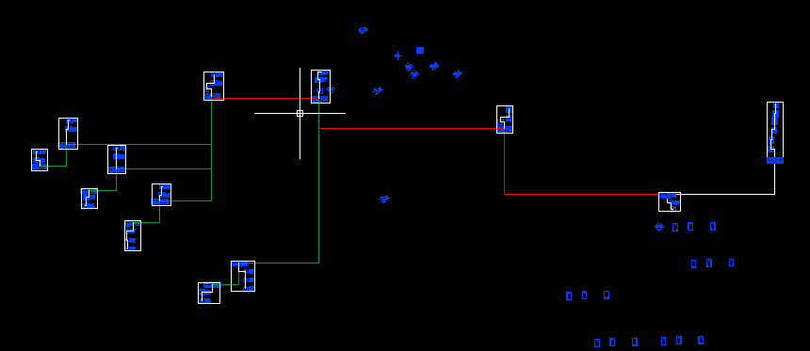

## Use VCONTROLLER to fill out data in blocks

* **Type VCONTROLLER into AutoCAD**
  1. Follow prompts to connect devices, some are multi line prompts
  2. Expand command line to read prompts
* **Select all blocks and cable in area to wire**

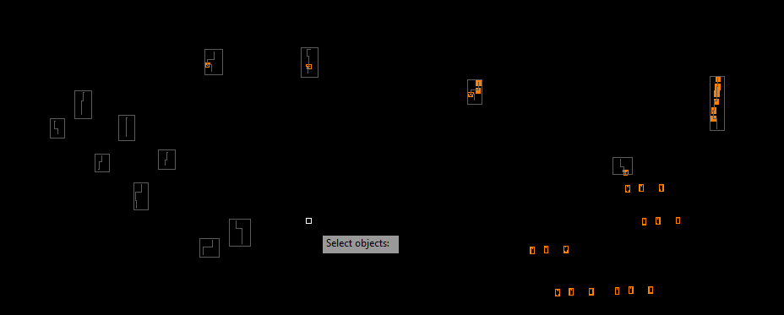

* **Select 1 controller to wire station bus devices to**
  1. The controllers are in orange
  2. Make sure to select only 1 controller
  3. You can select station bus devices, panel devices or cable.
  4. The code will ignore anything that is not orange to make things easier

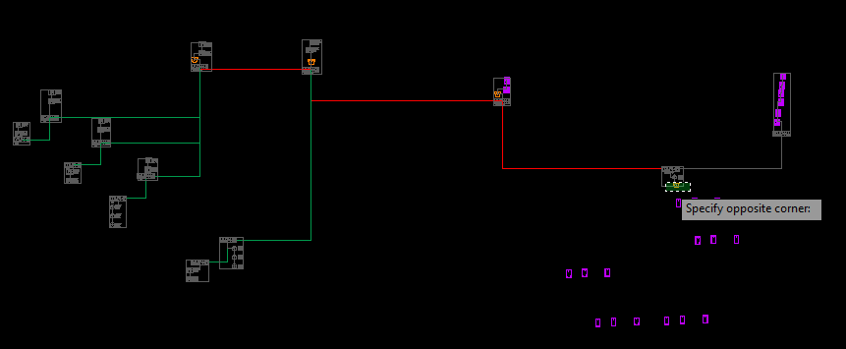

* **Type Enter**

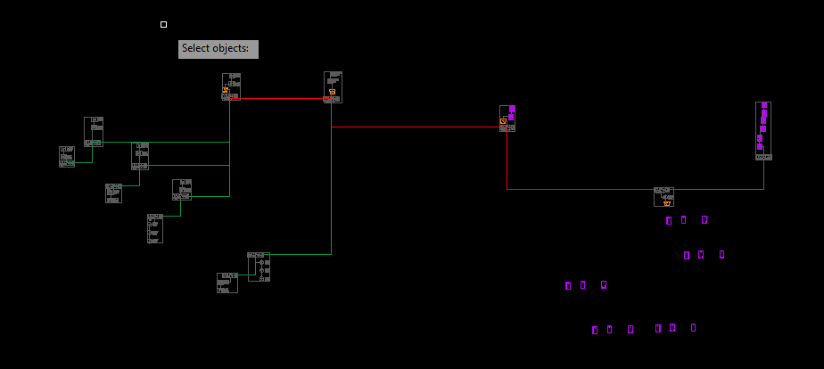

* **Select station bus devices for Bus Run 1**
  1. You can select anything
  2. The code will ignore everything except station bus devices

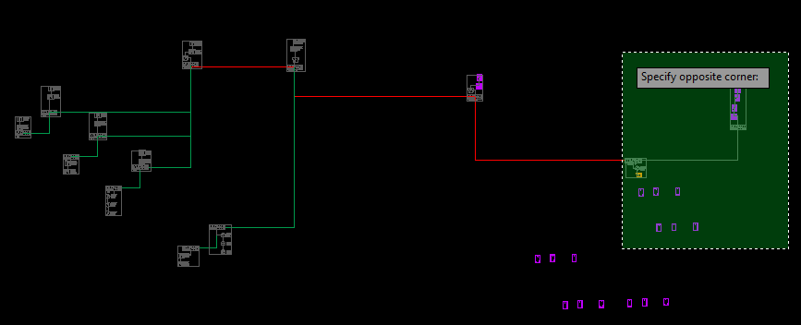

* **Type Enter**

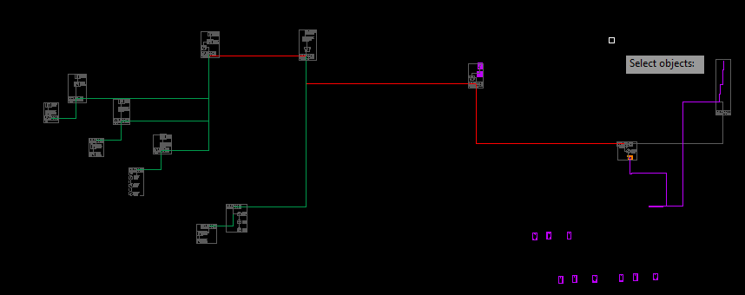

* **Select station bus devices for Bus Run 2**
  1. You can select anything
  2. The code will ignore everything except station bus devices
  3. You can skip Bus Run 2 by typing enter without selecting anything

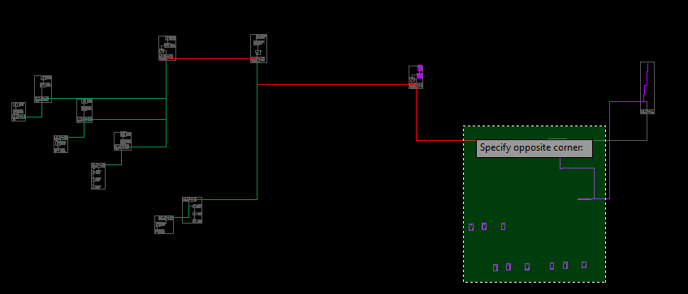

* **Type Enter**

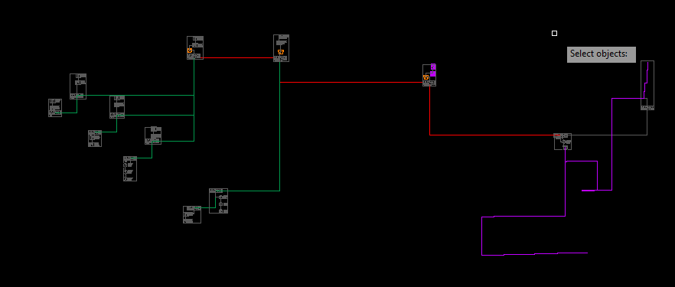

* **Repeat with next controller** 
  1. You can exit anytime you are finished
  2. The loop will terminate when you run out of controllers
  3. You can skip Bus Run 2 for any controller by typing enter without selecting any station bus objects

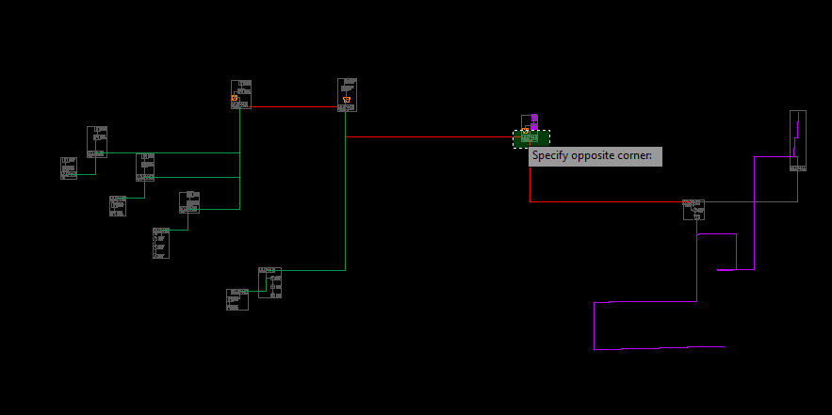

* **VCONTROLLER complete**

## Create extraction from RISERLAYOUT.dwg

* **In the RISER-LAYOUT.dwg type EBLOCKVANTAGE**

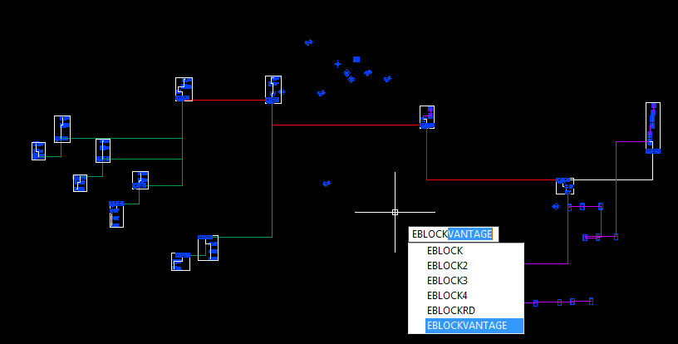

## Use GSRVANTAGE from blank template file

* **Save blank SL-VANTAGE.dwg template file in your project folder**
  1. The RISERLAYOUT command creates one in your project folder
  2. You can also save or copy one manually if you need to
  3. Be sure that the Vantage_Riser_Extraction.txt, and SL-VANTAGE.dwg template are saved in the same folder
* **Type GSRVANTAGE**
  1. This command creates the Riser and necessary viewports
  2. Double check all viewports and make necessary adjustments before plotting

.

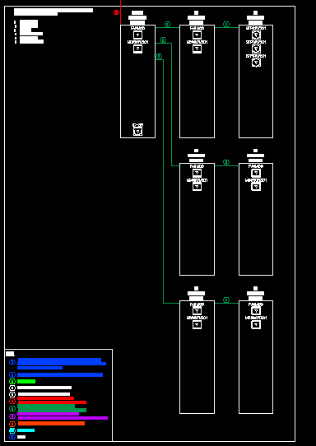.

* **Shrink viewports if needed**
  1. Double check all viewports and make necessary adjustments before plotting
  2. The bottom edge of the previous panel system will show depending on the ratio of the viewport
  3. Drag the bottom left corner of the viewport up to fix this

